Morgan Plus Four Brings First Sennheiser In-Car Audio System to U.S.

Debuting at Monterey Car Week, the Handcrafted British Sports Car Pairs Analog Performance With Pure Sennheiser Sound For the First Time On American Roads

LOS ANGELES – August 6, 2025 – Sennheiser, a leading provider of professional audio technology for 80 years, proudly announced a new milestone in its collaboration blending British craftsmanship with German audio engineering. Morgan Motor Company and Sennheiser have unveiled the arrival of the Morgan Plus Four in the United States, marking a new chapter for both brands. This launch introduces the first-ever Sennheiser in-car sound system available to U.S. customers, bringing the brand’s remarkable audio experience to American roads for the very first time.
The Morgan Plus Four with its integrated Sennheiser sound system will make a special appearance at Monterey Car Week 2025, running from August 8-17, 2025, a prestigious automotive event in Monterey County, California, where attendees can experience its timeless design, exhilarating performance, and innovative Sennheiser sound system firsthand.
“For Morgan owners, driving is as much about emotion and connection as it is about performance and craftsmanship,” said Matthew Hole, Managing Director at Morgan Motor Company. “Given the tactile, engaging and timeless nature of Morgan sports cars, it is imperative that a high-quality audio system complements the experience rather than competes with it.”

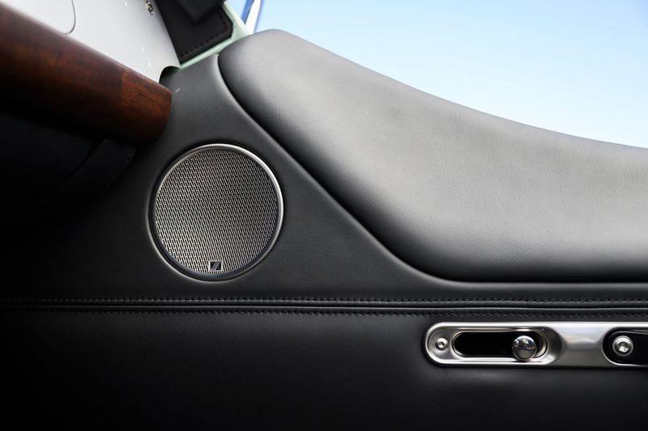
Sennheiser Mobility and Morgan collaborated to integrate discreet bass actuators beneath each seat and a compact subwoofer tucked within the chassis of the Plus Four

This U.S. debut builds on Sennheiser’s pioneering AMBEO debut on the 2020 Karma Revero GT, first showcased during Monterey Car Week in 2019. Veronique Larcher, Managing Director at Sennheiser Mobility, stated, “Sennheiser is synonymous with premium sound, and we’re excited to bring our in-car audio expertise to the U.S. market through our continued partnership with Morgan Motor Company. The Morgan Plus Four is a car that speaks to the senses, and our sound system ensures that hearing is no exception.”

The partnership, which began more than three years ago when Morgan sought out an advanced sound system solution for its bespoke sports cars, maintains a clear focus on design with technological excellence. The Sennheiser sound creates a natural and enveloping sound experience, aligning with Morgan’s unique blend of craft, adventure, and analog driving experience.

Developed with a focus on maintaining Morgan’s design integrity, the Sennheiser audio system posed unique engineering challenges due to Morgan’s lightweight, hand-crafted, and intentionally minimalist vehicles, which can make rich bass reproduction difficult. To address this, Sennheiser Mobility and Morgan collaborated to integrate discreet bass actuators beneath each seat and a compact subwoofer tucked within the chassis.

Sennheiser helped Morgan address packaging and acoustic limitations with a lightweight solution that delivers the deep, immersive bass without compromising the car’s balance or aesthetics. The result is a pioneering approach that sets a new benchmark not just for Morgan, but for the wider automotive world of lightweight sports cars.
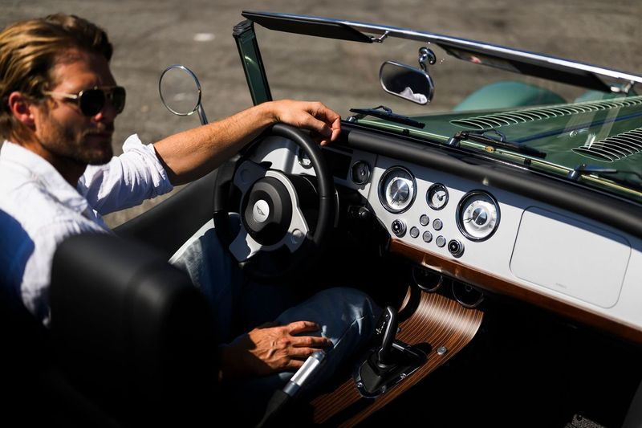
Sennheiser helped Morgan address packaging and acoustic limitations with a lightweight solution that delivers the deep, immersive bass without compromising the car’s balance or aesthetics

Tuning played a central role, utilizing Sennheiser’s state-of-the art audio algorithms to design a cabin-tailored experience for both roof-up or roof-down listening, enhancing every journey with a truly remarkable audio environment that feels more like a home theater than a traditional car. Expanded volume dynamics and extended Bluetooth range ensure reliable performance in a variety of driving conditions.

Ease of use was also a key development factor. Playback functions, such as pause and track skip, are accessible through the vehicle’s existing volume dial, eliminating the need for additional controls. Visual feedback is provided via the LCD screen, where track information and volume levels are displayed clearly and intuitively, supporting a seamless, distraction-free driving experience.

“Our work with Sennheiser represents everything we strive for in creating unique automotive experiences,” said Matthew Hole, Managing Director at Morgan Motor Company. “Going beyond a normal sound system, the company’s work with Morgan is centered around crafting a seamless, evocative atmosphere that supports the unique character of the vehicle. We’re proud to see this partnership reach the U.S., and excited to share it with drivers who truly appreciate the art and sound of driving.”

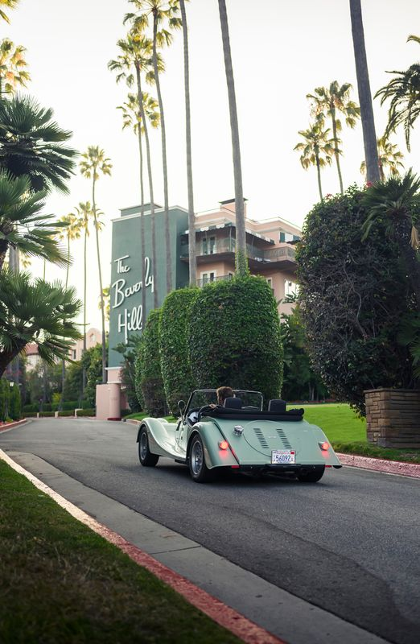
The Plus Four with its integrated Sennheiser sound system will make a special appearance at Monterey Car Week 2025

In addition to the Plus Four, Sennheiser audio is featured in Morgan’s Supersport and Midsummer models available in the EU and UK. Both brands view this partnership as a long-term platform for innovation.

The Morgan Plus Four with Sennheiser sound system is now available for order through select U.S. dealerships.

More information on Morgan Motor Company and the Plus Four is available at https://morgan-motor-usa.com/models/plus/plus-four/. Information regarding Sennheiser Mobility is available at https://www.sennheiser.com/en-us/mobility

###

Editor’s Note: The Plus Four is now available for media drives in the Los Angeles area by appointment. For more information or to schedule a test drive, please reach out to the PR contacts listed below.

About the Sennheiser Brand – 80 Years of Building the Future of Audio

We live and breathe audio. We are driven by the passion to create audio solutions that make a difference. This passion has taken us from the world’s greatest stages to the quietest listening rooms – and made Sennheiser the name behind audio that doesn’t just sound good: It feels true. In 2025, the Sennheiser brand celebrates its 80th anniversary. Since 1945, we stand for building the future of audio and bringing remarkable sound experiences to our customers.

While professional audio solutions such as microphones, meeting solutions, streaming technologies and monitoring systems are part of the business of Sennheiser electronic SE & Co. KG, the business with consumer devices such as headphones, soundbars and speech-enhanced hearables is operated by Sonova Holding AG under the license of Sennheiser.

www.sennheiser.com
www.sennheiser-hearing.com

Local Press Contacts:
Daniella Kohan
daniella.kohan@sennheiser.com
+1 (860) 227-2235

Peter Schuyler
Peter@ingearpr.com
+1 (917) 496-8970

